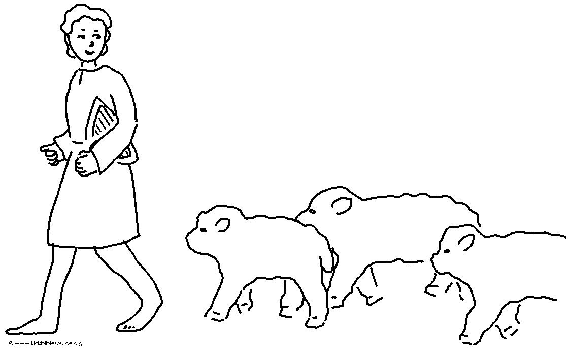
_ _ _ _ _ _ to my instruction and be _ _ _ _.
Don't _ _ _ _ _ _ it. Proverbs 8:33_{NLT}

